June 2012

Science and Technology

555-306

ANYONE WHO RECEIVES A COPY OF THIS EXAMINATION HAS

UNDERTAKEN TO USE IT ON THE FOLLOWING DATE:

Monday JUNE 18, 2012 a.m.

NOTE: This date was established by the Directors of English Education Network (DEEN) and the Mathematics and Science and Technology Committee (MaST).

 | Science and Technology – 555-306
Secondary Cycle 2, Year 1
(Secondary 3)
ST-300.A01

Theory Examination

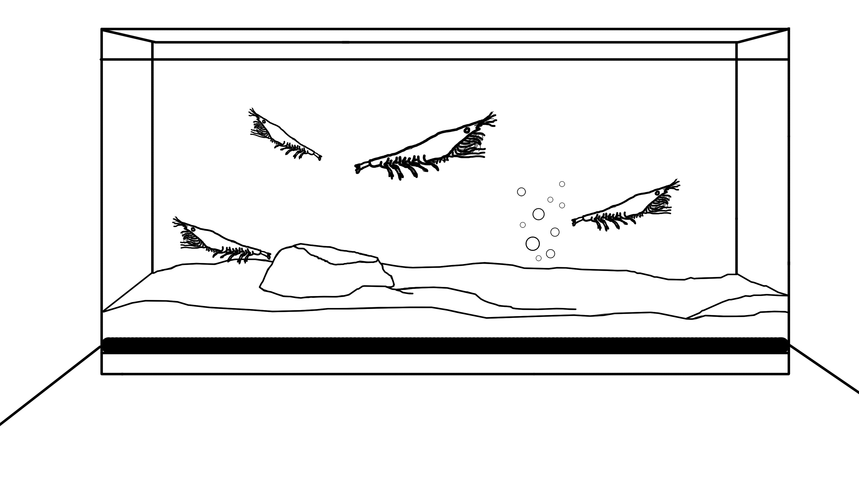

Administration and Marking Guide



Theory Examination
BIM ▪ Société GRICS ▪ 2012

Design Team
Lester B. Pearson School Board

Coordination
Katherine Davey, Science and Technology Consultant, Lester B. Pearson School Board
Michael Quinn, Science and Technology Consultant, Sir Wilfrid Laurier School Board

Validation
Imma Ienaro, Science and Technology Consultant, English Montreal School Board

Editing
Barbara Choquette, Evaluation Consultant, BIM, Société GRICS

Linguistic Revision
Kevin O’Donnell, Société GRICS

Layout and Computerization
Diane Nadeau, BIM, Société GRICS

Illustrations
Serge Hanna, BIM, Société GRICS
www.clipart.com

Table of Contents

General Information Page 1

Presentation of the Examination Page 2

Concepts Covered in the Examination Page 3

Scoring of the Examination Page 4

Examples of Appropriate Responses and Procedures Page 6

Appendix

Feedback Questionnaire
General Information

Title of the Examination
Science and Technology — 555-306 ▪ ST-300.A01

Cycle and Option
Secondary Cycle 2, Year 1 (Secondary 3)
Science and Technology, Theory Examination

Subject-Specific Competencies
- Makes the most of his/her knowledge of Science and Technology.
- Communicates in the languages used in Science and Technology.

Time Allotted
- 3 hours (An additional 15 minutes may be allotted if needed.)

Permitted Materials
The following materials are permitted during the examination:

- Calculators (without graphic displays)*
- Writing instruments
- Rulers
* To ensure fairness to all students, graphing calculators or any other type of calculator that stores information should not be used. Memory aids and electronic devices such as cell phones, MP3 players, cameras, etc., are prohibited.

Examination Documents
- Administration and Marking Guide
- Question Booklet
- Answer Booklet (All student work must be completed here.)
Presentation of the Examination

General Description
- This document provides all necessary information to evaluate the mastery of subject-specific knowledge as well as to evaluate the development of Competencies 2 and 3, of the Science and Technology program at the end of Secondary Cycle 2, Year 1. This theory examination was developed by a group of teachers, coordinated by MaST (Mathematics and Science and Technology Committee) and formatted by the Société GRICS.

- This theory examination requires students to demonstrate their proficiency in the subject-specific knowledge targeted in the Progression of Learning: the Material World, the Living World, the Earth and Space, and the Technological World.

- The examination consists of 25 questions in three parts:

 Part A: Multiple Choice Questions
 Part B: Constructed Response Questions
 Part C: Technological Analysis
- The questions evaluate the students’ acquisition of knowledge and his/her understanding, application and use of this knowledge. The three evaluation criteria to be considered in this examination are:

 Accurate interpretation of the problem
 Revelant use of scientific and technological knowledge
 Appropriate formulation of explanations

- This theory examination provides teachers with information that can help them evaluate the extent to which students have developed essential knowledge and subject-specific competencies in the Science and Technology program.

- Examples of appropriate procedures are provided.

Concepts Covered in the Examination
The Living World | The Material World | Earth and Space | The Technological  World
Systems  Nutrition  Respiratory system   Function and role  Circulatory system   Blood type compatibility   Blood constituents  Lymphatic system   Active immunity  Digestive system   Digestive tract   Types of foods  Lymphatic system   Active immunity  Relationships  Nervous system   Peripheral nervous system   Sensory receptors-eye  Musculoskeletal system   Functions   Types of muscles  Survival of Species  Cell division   Meiosis  Reproductive system   Hormones | Properties  Properties of Matter  Characteristic physical properties   Density   Properties of solutions  Changes in Matter  Particle model  Physical change   Dilution  Chemical change   Types of changes  Waves   Frequency   Wavelength   Amplitude   Deviation of light waves  Fluids   Pressure and volume | Characteristics of the Earth  Lithosphere   Fossil formation | Graphical Language  Orthogonal Projections   Isometric and mutliview  Materials  Mechanical properties of materials   Constraints   Types and properties of materials  Mechanical Engineering   Typical functions   Motion transmission systems   Guiding controls

Weighting Table
Content  Question | The Living World | The Material World | The Earth  and Space | The Technological  World
Weighting | 48% | 28% | 4% | 20%

Scoring of the Examination

Marking Guide

GUIDELINES FOR CORRECTING QUESTIONS

The marking scale for correcting the answers to the examination questions is presented below, along with explanations of the terms used in the scale.

It is IMPORTANT that the teacher read this information carefully before correcting the examination.

Questions usually consist of two parts: the procedure used to solve the problem and the answer. Thus, a question should be corrected in two steps.

Step 1

Analyze the work to understand the procedure used by the student, and then decide if the procedure is appropriate or not.

A procedure is appropriate if the steps presented could lead to the correct answer.

A procedure is partially appropriate if the steps presented do not lead to the correct answer, but include at least one step that is relevant and correct.

A procedure is inappropriate if none of the steps presented are relevant, or if the student has not shown any work.

Step 2

If the procedure is deemed appropriate, then evaluate the answer. If the answer is incorrect, identify the type of error made.

The error is considered minor if it is an error in calculation or transcription, if the unit of measurement is incorrect or missing, or if the student has rounded off a number incorrectly.

The error is considered major if a law, rule, or formula has been applied incorrectly.

No marks are allotted for a correct answer when the procedure used is inappropriate.

Part A
Multiple Choice Questions

Question 1 D

Question 2 A

Question 3 C

Question 4 A

Question 5 D

Question 6 B

Question 7 A

Question 8 C

Question 9 B

Question 10 C

Question 11 B

Question 12 D

Question 13 D

Part B
Constructed Response Questions

Question 14

Example of an appropriate response
a)

Constituent  Number | Name | Function
1 | Red Blood Cell | Transports O₂.
2 | Platelets | Assists in blood coagulation.

Marking Scale
2 marks | Appropriate response and correct answer.
1 mark | Partially appropriate response. Both components correctly named OR name and function of one component correctly identified.
0 marks | Inappropriate response or did not provide a response.

b) An individual with a viral infection would be expected to have an increase number of white blood cells. These extra white blood cells would have been recruited to fight the infection.

Marking Scale
2 marks | Appropriate and complete response. Identifies increase in white blood cells AND reason for the increase.
1 mark | Partially appropriate response. Identifies increase in white blood cells OR identifies the function of white blood cells.
0 marks | Inappropriate response or did not provide a response.

Question 15

Example of an appropriate response

The crew should pack the Isaac Bar for the scuba diving excursion.

Marking Scale
1 mark | Appropriate response and correct answer.
0 marks | Inappropriate response or did not provide a response.

The scuba divers require a snack that is low in fat and that supplies energy to the body quickly. Carbohydrates are the food type that provides energy to the body quickly. The Isaac Bar is the food that is lowest in fat (only 4 g per 50 g) and has high carbohydrate content (35 g per 50 g.)

Marking Scale
3 marks | Appropriate response and correct answer.
2 marks | Partially appropriate response. Identified content of carbohydrates AND fats only.
1 mark | Partially appropriate and incompleted procedure. Identified content of carbohydrates OR fats only.
0 marks | Inappropriate response or did not provide a response.

Question 16

Example of an appropriate response

a) Path through respiratory tract

nose (mouth) → pharynx → trachea → bronchi → lungs

- Do not penalize students for including larynx.
- A more advanced answer may include nasal cavities, bronchioles and alveoli.

Marking Scale
2 marks | Appropriate response and correct answer. Lists all organs in correct order.
1 mark | Partially appropriate response. Lists most organs in order (1 or 2 missing or out of order).
0 marks | Inappropriate response or did not provide a response.

b) Diagram of labelled alveolus

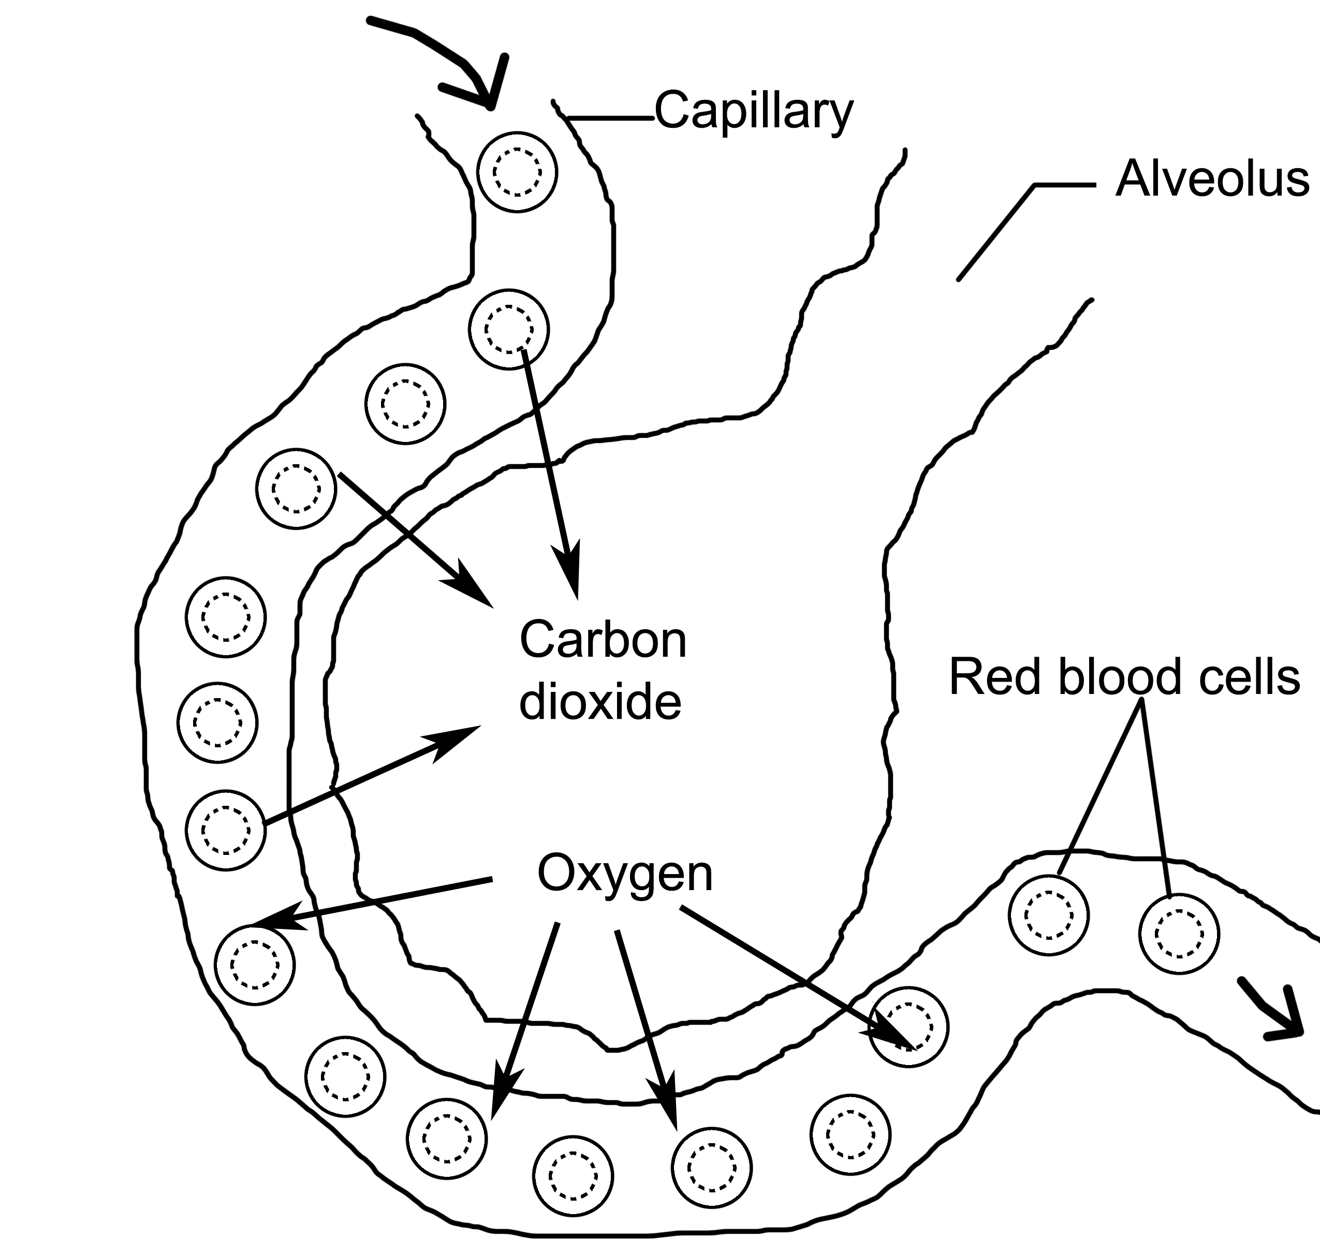

Marking Scale
2 marks | Appropriate response and correct answer. Identifies gases and arrows correctly.
1 mark | Partially appropriate response. Correctly identifies gases only.
0 marks | Inappropriate response or did not provide a response.

Question 17

Example of an appropriate response

a)
Scuba Tank Before Re-Filling | Scuba Tank After Re-Filling
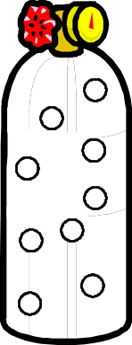 | 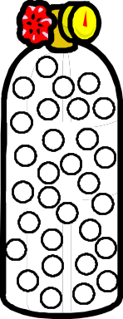

- Number of particles need to be significantly higher in AFTER tank.
- A more advanced answer might also include arrows indicating particle movement (and might even be longer in the BEFORE tank and shorter in the AFTER tank).

Marking Scale
1 mark | Appropriate response and correct answer. Indicates a significant increased number of particles in the after tank.
0 marks | Inappropriate response or did not provide a response.

b) Particle model

When the tank is re-filled, more air particles are being placed into the tank. The more particles there are, the more frequently they will collide, causing an increase in pressure. (Nothing is mentioned about temperature so the speed of particle movement can’t be discussed, and the container volume will not change so that will not affect pressure).

Marking Scale
3 marks | Appropriate response and correct answer. Identifies that pressure increases AND completely describes the relationship between increased particle numbers and increased pressure.
2 marks | Partially appropriate response. Identifies that pressure increases. Describes the relationship between increased particle numbers and increased pressure (includes partially incorrect information).
1 mark | Partially appropriate response. Identifies that pressure increases. Does not provide appropriate explanation.
0 marks | Inappropriate response or did not provide a response.

Question 18

Example of an appropriate procedure

Concentration of Sample A:
1 L = 1000 mL
? L = 120 mL

120 mL ÷ 1000 = 0.120 L

C = m/V
C = 4.32 g/0.120 L
C = 36 g/L

From the graph, this corresponds to a depth 200 m.

Concentration of Sample B:

C = m/V
C= 7.65 g/0.225 L
C= 34 g/L

From the graph, this corresponds to a depth of 1000 m.

Sample A was taken from a depth of 200 m.
Sample B was taken from a depth of 1000 m.

Marking Scale
4 marks | Appropriate procedure and correct answer.
3 marks | Appropriate procedure with a minor error in calculation or transcription or incorrect or missing unit.
2 marks | Partially appropriate procedure with a major error. A law, rule or formula has been applied incorrectly.
1 mark | Incomplete procedure.
0 marks | Inappropriate response or did not provide a response.

Question 19

Example of an appropriate response

Sound wave #1 belongs to the Humpback Whale.
Sound wave #2 belongs to the Beluga Whale.

Marking Scale
2 marks | Appropriate response and correct answer.
1 mark | Partially appropriate. Identifies one sound wave correctly.
0 marks | Inappropriate response or did not provide a response.

Justification:

Sound wave #1 has lower frequencies or longer wavelengths. It represents the Humpback Whale.

Sound wave #2 has higher frequencies or shorter wavelengths. It represents the Beluga Whale.

Marking Scale
2 marks | Appropriate response and correct answer.
0 marks | Inappropriate response or did not provide a response.

Question 20

Example of an appropriate response:

a) Refraction phenomena

The probe looks broken because of refraction, or the deviation of light waves in the water. When light passes from one transluscent material (water) to another (air) of different densities, it changes speed and therefore deviates from its original direction.

Marking Scale
2 marks | Appropriate response and correct answer. Identifies and explains refraction correctly.
1 mark | Partially appropriate response. Correctly identifies refraction only.
0 marks | Inappropriate response or did not provide a response.

b) Path of light rays

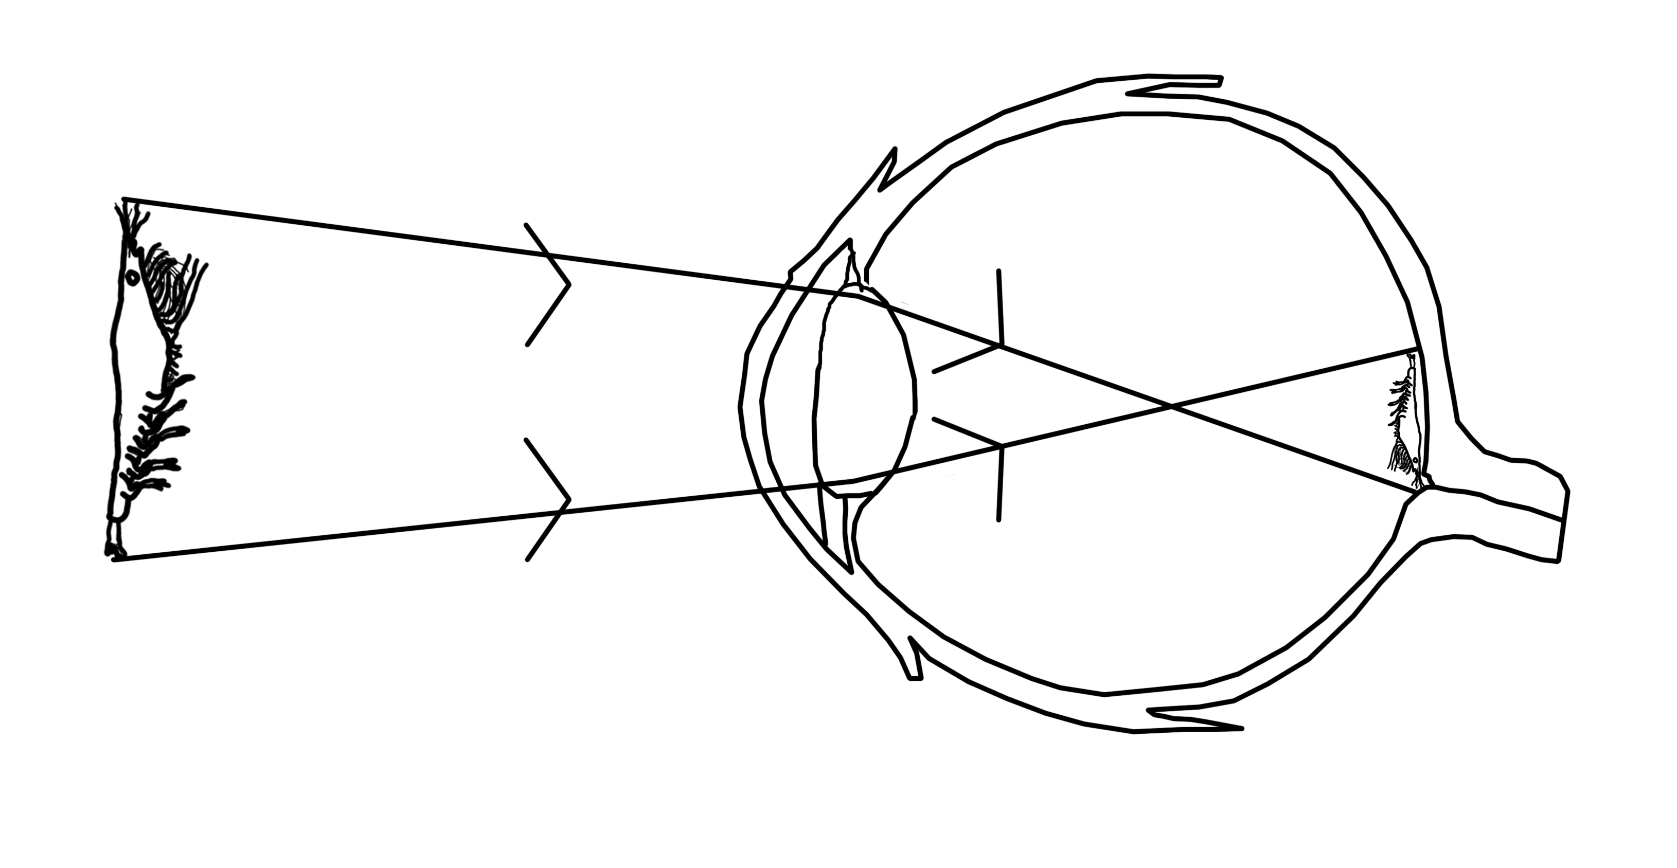

Explanation

The crystalline lens in the eye is convex. When the light travels through the lens, it deviates, causing the light ray from the head of the krill to be at the bottom of the retina, and the light ray from the tail to be at the top of the retina. Therefore, the image on the retina is inverted.

Marking Scale
2 marks | Appropriate response and correct answer. Identifies rays and explains image inversion correctly.
1 mark | Partially appropriate response. Correctly draws rays OR explains image inversion.
0 marks | Inappropriate response or did not provide a response.

Question 21

Example of an appropriate response

a) Formation of fossils

A layer of sediment was deposited and the remains of animals were trapped within them. The animal remains were transformed into fossils. Subsequent layers of sediment were deposited above. These newer layers of sediment also trapped more recent animal remains and then were transformed into newer sedimentary rocks.

Marking Scale
2 marks | Appropriate response and correct answer.
1 mark | Partially appropriate response. Incomplete explanation.
0 marks | Inappropriate response or did not provide a response.

b) The Trilobite is the oldest fossil.

Explanation

The Trilobite is located in the bottom stratigraphic layer. The lower rock layers, and the fossils contained within them, are older than the fossils from the upper rock layers.

Marking Scale
2 marks | Appropriate response and correct answer. Identifies Trilobite and explains correctly.
1 mark | Partially appropriate response. Only identifies Trilobite.
0 marks | Inappropriate response or did not provide a response.

Part C
Technological Analysis

Question 22

Example of an appropriate response
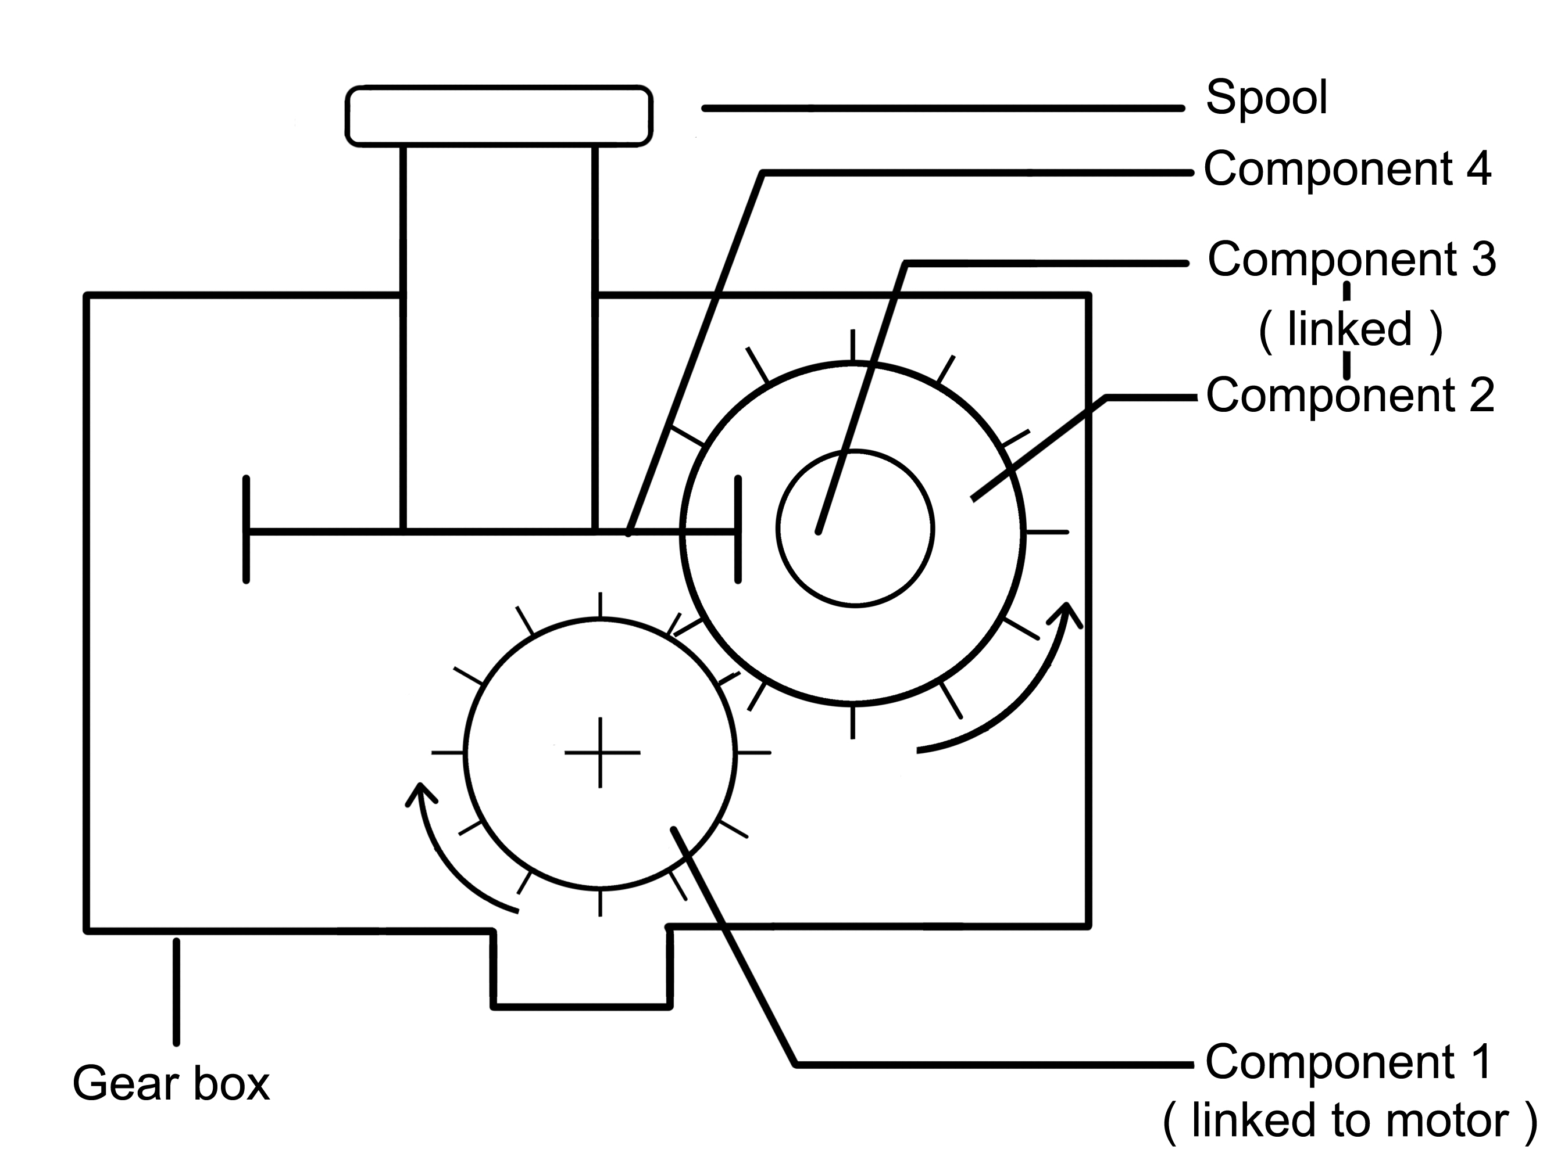

a) i. The name of component 1 is a gear.

ii. The symbol to indicate the motion of component 2 is .

When component 1 rotates in a clockwise direction, component 2 rotates in a counterclockwise direction.

iii. The motion transmission system formed by components 1 and 2 is a gear train.

Marking Scale
3 marks | Appropriate response and correct answer.
2 marks | Partially appropriate response. Identified two elements correctly.
1 mark | Partially appropriate response. Identified one element correctly.
0 marks | Inappropriate response or did not provide a response.

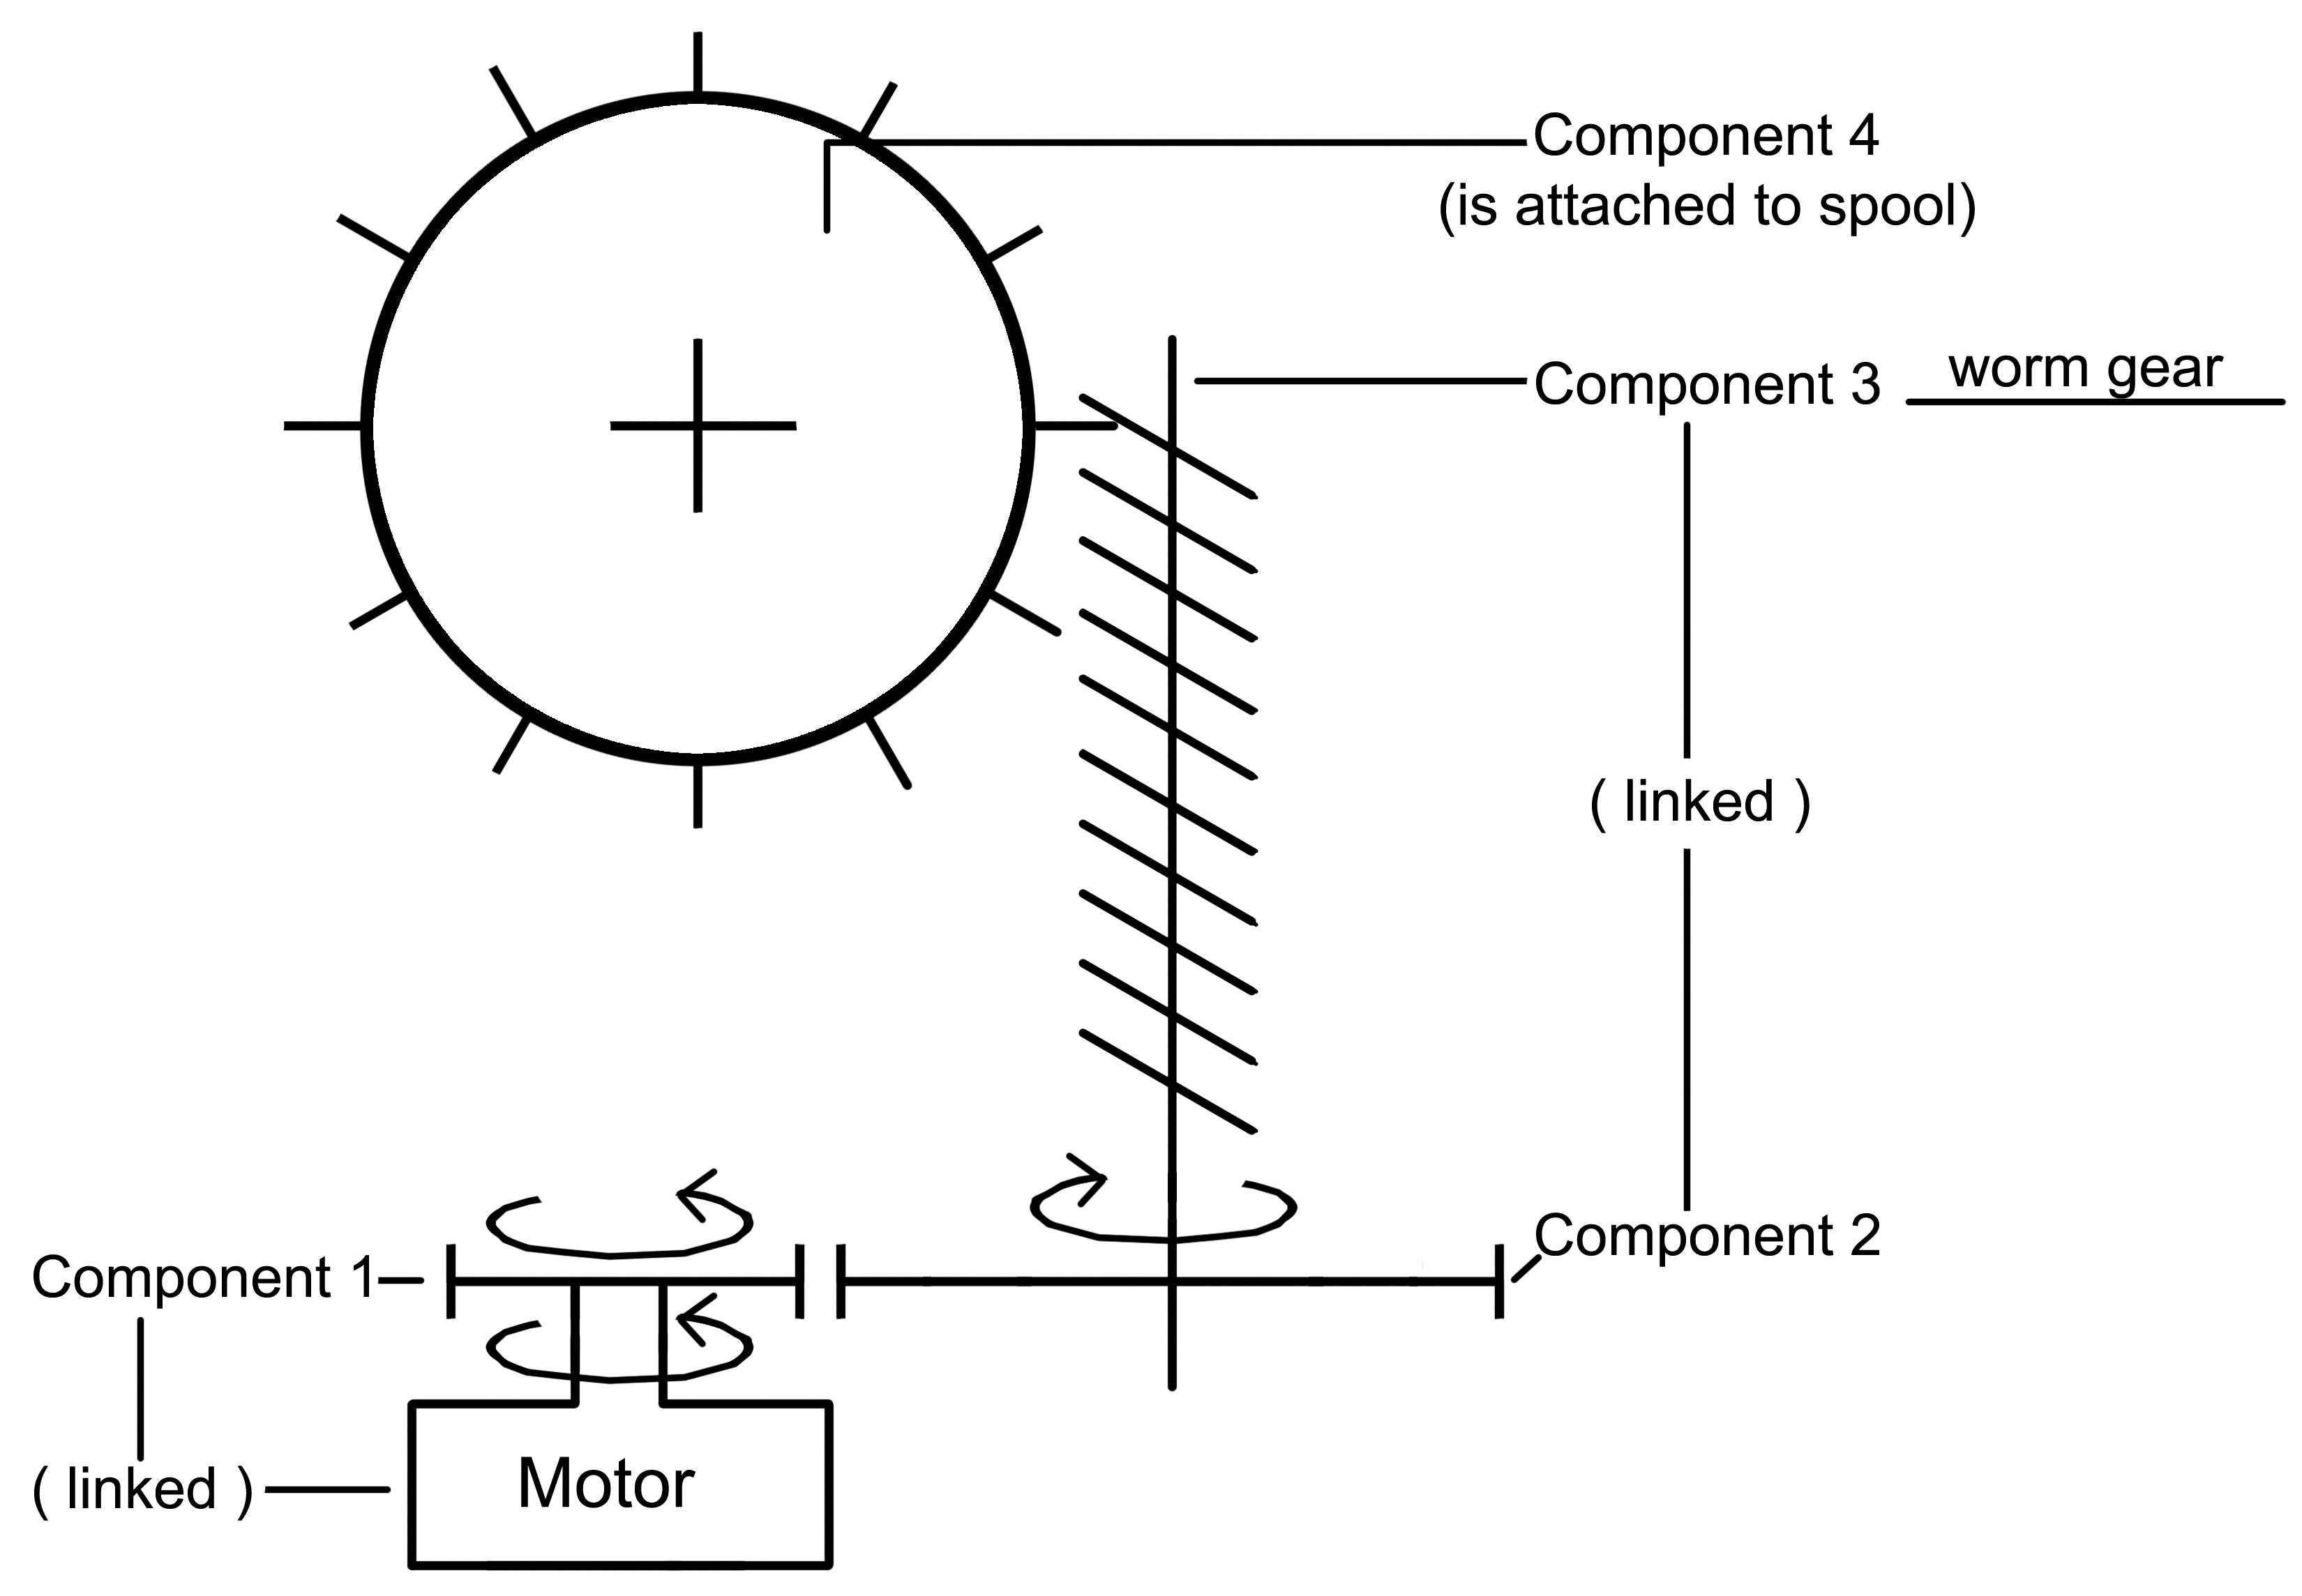

b) i. The name of component 3 is a worm gear.

ii. Component 3 rotates faster.

iii. This is because one full rotation of component 3 results in a fraction of a rotation of component 4.

Marking Scale
3 marks | Appropriate response and correct answer.
2 marks | Partially appropriate response. Identified two elements correctly.
1 mark | Partially appropriate response. Identified one element correctly.
0 marks | Inappropriate response or did not provide a response.

Question 23

Example of two appropriate responses

Change 1: Use a motor that rotates at a slower rate.

Explanation: If the motor rotates at a slower rate then component 1 will rotate at a slower rate, as will all other components. When the spool rotates at a slower rate, the cable will be unwrapped at a slower rate, resulting in the objects being lowered at a slower rate into the water.

Change 2: Use a larger diameter gear for component 2.

Explanation: When the rotational motion is transferred from component 1 to component 2, there is a reduction in the speed of rotation because the driven gear (component 2) has a larger diameter than the driver gear (component 1). If the diameter of component 2 is increased, then the reduction in speed will be greater, and component 2 will rotate at a slower rate. As a result, the spool will rotate at a slower rate and the cable will be unwrapped at a slower rate, resulting in the objects being lowered at a slower rate into the water.

Accept any other appropriate change and explanation.

Marking Scale
2 marks | Appropriate change described with an appropriate explanation.
1 mark | Appropriate change described without an appropriate explanation.
0 marks | An inappropriate change is described or no answer is given.

Question 24

a)
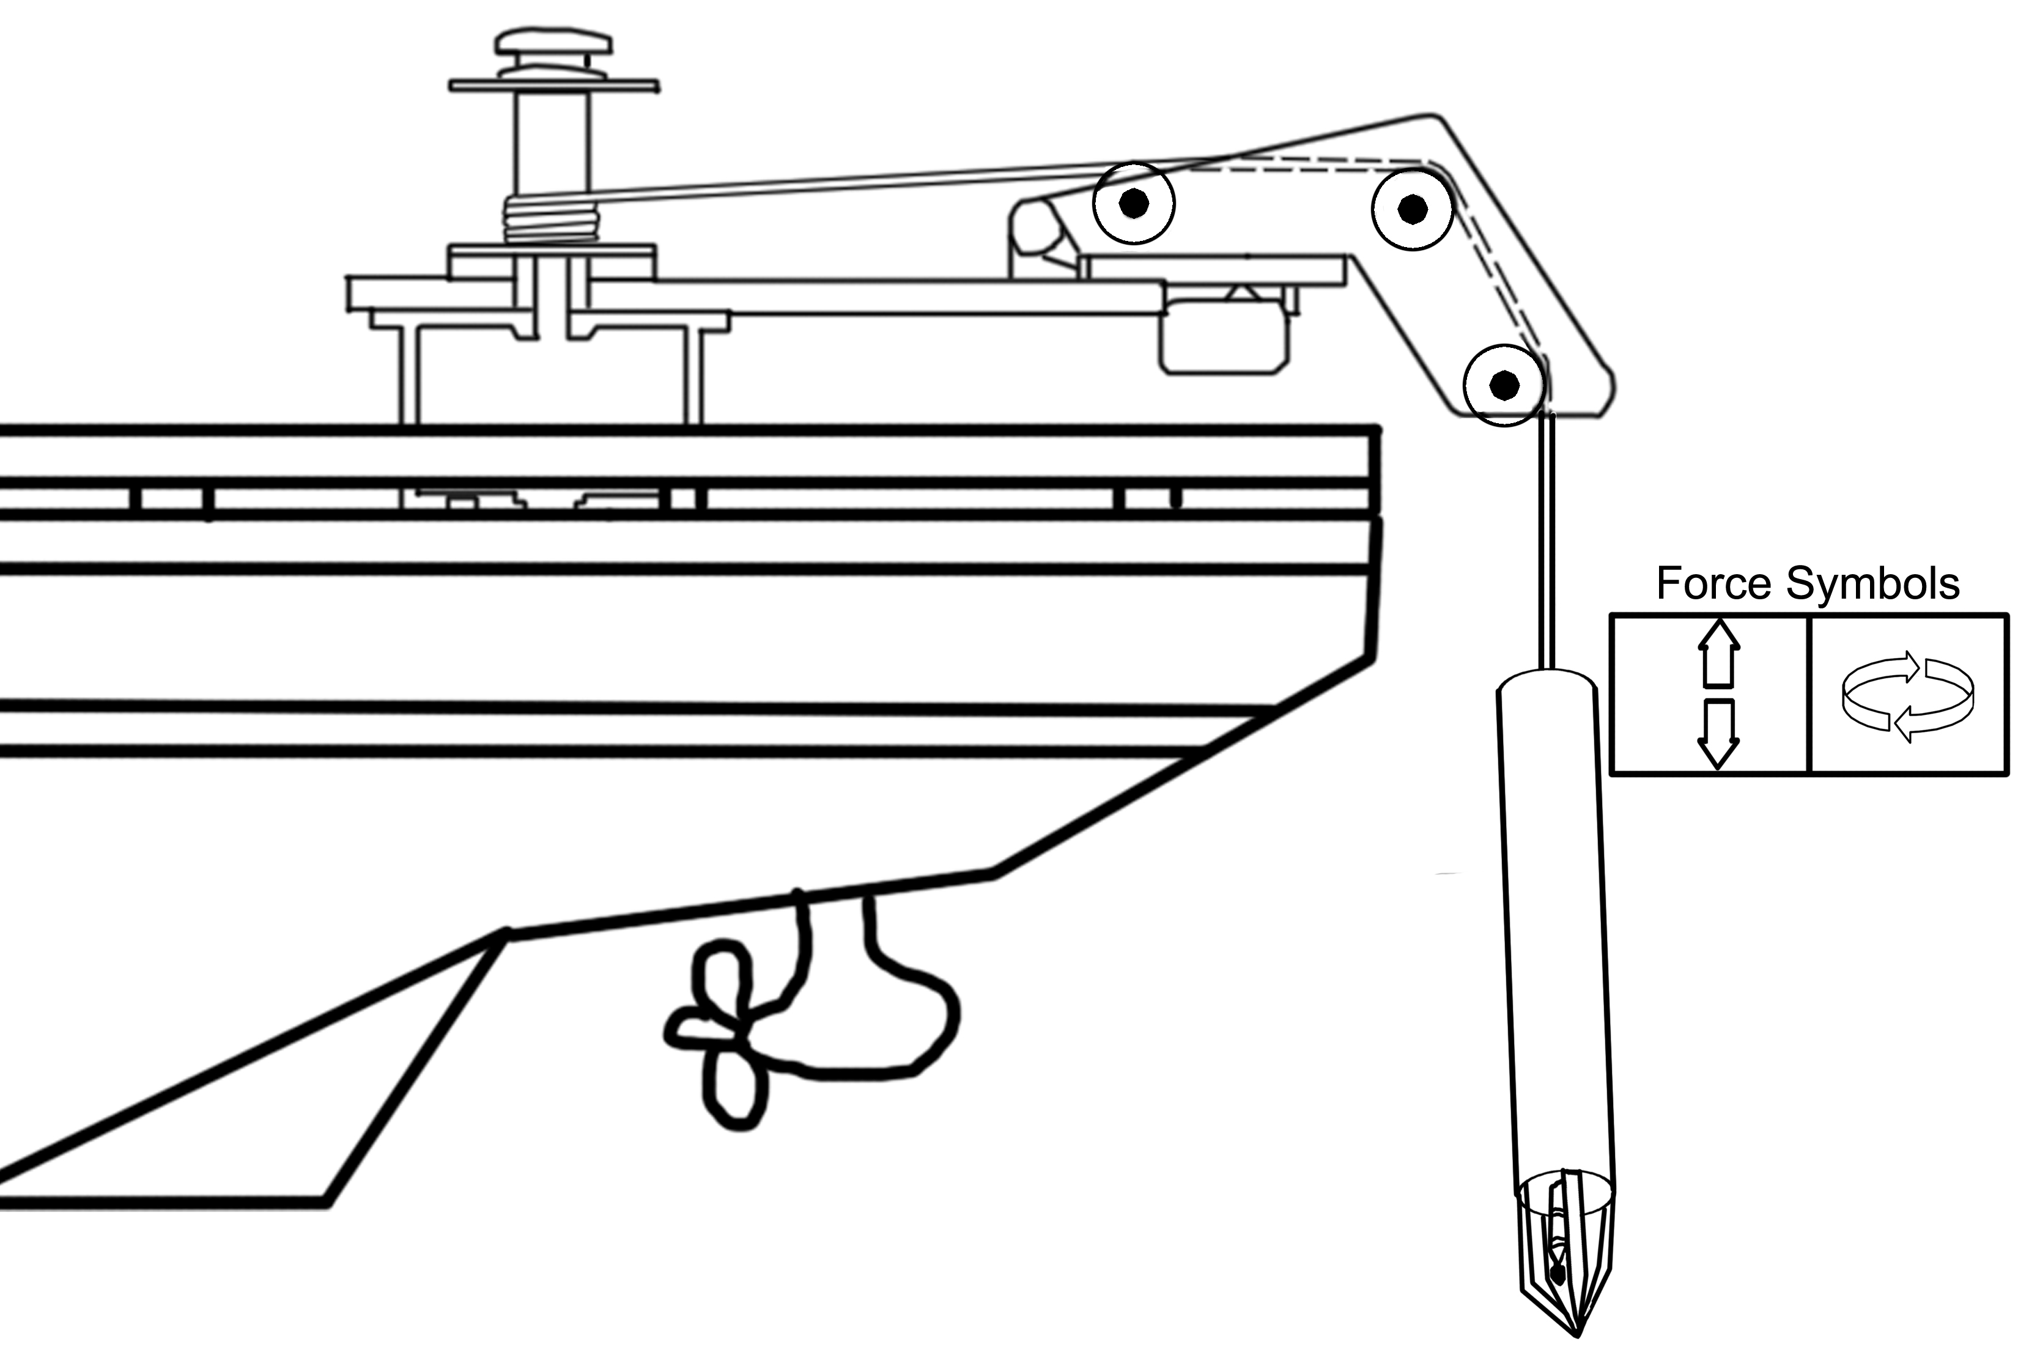

Marking Scale
2 marks | Appropriate response and correct answer.
1 mark | Inappropriate response. Identifies one force symbol correctly.
0 marks | Inappropriate response or did not provide a response.

b) Two constraints to which the cable was subjected are:

i) Tension
ii) Torsion

Marking Scale
2 marks | Appropriate response and correct answer.
1 mark | Inappropriate response. Identifies one constraint correctly.
0 marks | Inappropriate response or did not provide a response.

Question 25

Example of an appropriate response

The best metal for the anchor is stainless steel.

Stainless steel has a high density, therefore, it will stay where it is dropped. It is resistant to corrosion, which is an important property to consider as the anchor will be in and out of water, and rusting is a major issue. In addition, properties such as hardness and rigidity are vital in order to prevent damage to the anchor as it may hit rocks etc.

Cast iron is a poor choice, as it will corrode easily even though it is has a high density.
Although aluminum is resistant to corrosion, the density is too low.
Titanium is also resistant to corrosion. However, the density is lower than that of stainless steel.

Marking Scale
4 marks | Appropriate response and correct explanation.
3 marks | Appropriate response with a partial explanation.
2 marks | Appropriate response with one explanation.
1 mark | Appropriate response with no explanation.
0 marks | Inappropriate response or did not provide a response.

Appendix
Feedback Questionnaire (EMSB)
Science and Technology – Secondary Cycle 2 Year 1
Theory Examination – June 2012

Please comment on the following:

1. Time allotted for theory examination:

2. Students’ level of interest:

3. Level of difficulty:

4. Administration and Marking Guide (quality and clarity):

5. Other comments:

6. Please list any errors or omissions:

Please return questionnaire to your school board Science and Technology consultant.
Thank You.

